**Item 13 – The UK Community Ownership Fund**

Councillor leading the discussion, Mike Mann

Purpose of the Discussion to:

**1. Discuss and agree APC role (3 mins)**

**Recommendation** - although APC is not eligible to apply for the funding we should take a pro-active role in identifying and assisting potential candidates. E.G tennis club, cricket club etc.

**2. Gather initial ideas (3 mins)**

Quick brainstorm to identify initial ideas, but no discussion about each at this stage.

**3. Agree outline plan / next steps (4 mins)**

* Finalise list of potential candidates
* Approach candidates
* Provide application support

**Please see paper from Cumbria County Council below.**

**Briefing**

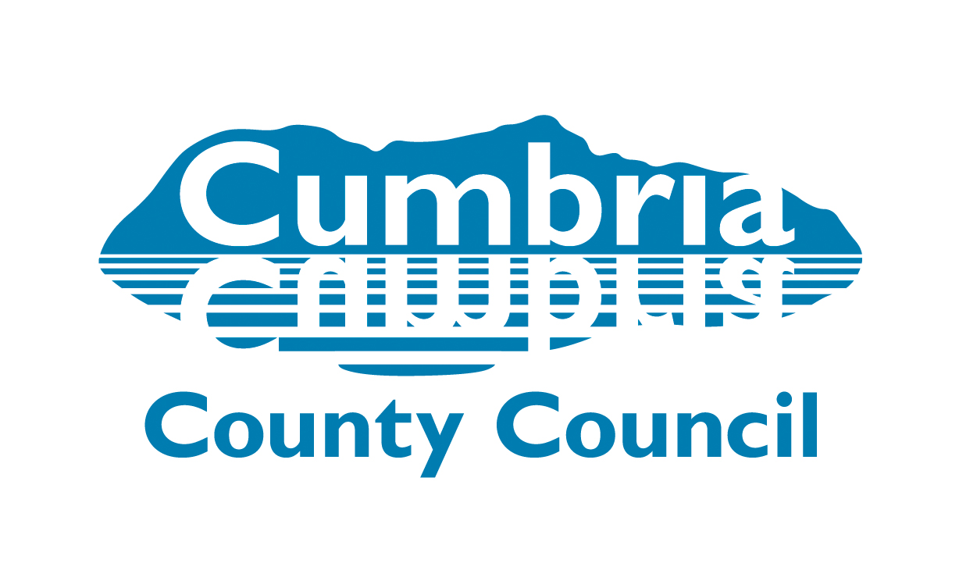

**Date 19 July 2021**

**Title:** UK Community Ownership Fund: prospectus 2021-22

**Author:** Martin Allman, Cumbria County Council

**Unit / Directorate:** Economy and Infrastructure

**Audience:** Lead Members

**1.0 Purpose**

To provide information on the UK Community Ownership Fund (COF) Prospectus for 2021/22.

**2.0 Background**

This Fund will comprise £150 million of investment across the United Kingdom to help communities take ownership of assets and amenities at risk of closure. It will run for 4 years.

Voluntary and community organisations can bid for up to £250,000 match funding (or up to £1 million for sporting venues) on a pound-for-pound basis. Match can be from a range of sources including, public, private and charitable funds, and certain in-kind match funding can be included (for example, professional support or a discounted value of a lease).

Funding may support the purchase and/or renovation costs of community assets and amenities, subject to the full eligibility criteria.

**3.0 Investment priorities**

The fund will support a range of community ownership proposals. For example, projects may include:

* sporting and leisure facilities
* cinemas and theatres
* music venues
* museums and galleries
* parks
* pubs
* post office buildings
* shops

Proposals will need to prove the value of the asset to local people and its sustainable, long-term benefit to the community.

The Fund will run until 2024/25 and there will be at least 8 bidding rounds. The date for submitting applications to the first round is 13 August 2021. Further rounds will be December 2021 and May 2022. An updated prospectus will be published for Round 2 in the autumn which the government states will be amended to ensure that the Fund has the reach and impact intended.

Up to £50,000 (and no more than 20% of the total capital costs applied for through the Fund) is available for project development costs (eg – surveyor or legal fees) and post-acquisition support (to support initial operational costs).

**4.0 Strategic Objectives and Eligibility**

The COF has 4 strategic objectives:

* provide targeted investment for communities to save assets that would otherwise be lost,
* strengthen capacity and capability in communities to support them to shape their places and develop sustainable community businesses,
* empower communities in left behind places to level up,
* strengthen direct links between places across the UK and the UK government.

To be eligible for investment from the Fund, the terms of community ownership must be either the freehold ownership or a long-term leasehold of at least 25 years minimum (with no break clauses).

Applicants must demonstrate that the asset they want to save fulfils the following criteria:

**There is a risk of loss without community intervention –** applicants will need to demonstrate the nature of the risk facing the asset. This will include evidence that without community intervention the asset or amenity would be lost to the community.

**Community value**

Applicants will need to show the contribution of the asset to their community including to the social wellbeing or cultural, recreational or sporting interests.

**Community use**

The asset will be used and accessed by the community or have had a community use in the recent past.

**Long-term sustainability**

Applicants will be required to demonstrate a clear plan for how the asset can be sustainable in community ownership in the long-term.

The Fund will also support projects which fulfil one or a combination of the following:

* acquire a physical community asset or facility at risk, such as land and buildings which deliver a benefit to local people,
* renovate, repair or refurbish the asset, only where this is part of a sale or transfer to save an asset at risk and where this is critical to saving it and making it sustainable,
* set up a new community business or buy an existing business in order to save an asset or amenity of importance to the community,
* the purchase of associated stock, collections or intellectual property, where it is associated with buying a physical asset or buying a business to save an amenity,
* move a community amenity to a new, more appropriate location within the same community to gain better value or because the venue is in itself an asset of community value.

There will not be a definitive list of assets that will be eligible and it will be up to applicants to show how the asset benefits their community.

The COF will not provide funding to:

* pay off businesses’ debts or to buy an indebted business
* purchase housing assets
* new-build projects to develop new assets or amenities, unrelated to saving or preserving an existing asset or amenity
* general revenue for community activities or events unrelated to the acquisition or transfer of a community asset or amenity
* purchase costs of publicly-owned assets.

The COF will consider applications from voluntary and community organisations from all parts of the United Kingdom who have a viable plan for taking ownership of a community asset at risk and running it sustainably for community benefit.

The legal structures of organisations across the United Kingdom we might expect to apply include the following:

* a charitable incorporated organisation (CIO)
* Co-operatives including Community Benefit Societies
* Community Interest Company (CiC)
* not-for-profit company limited by guarantee

Local authorities and town, parish and community councils will not be eligible to apply. However, government hopes that councils will play an active role in supporting their local community groups to apply.

**5.0 Role of the Council**

Although the Council is not eligible to apply for the funding it could take a pro-active role in supporting local communities in applying for the fund to three ways:

* Via the Cumbria Social Enterprise Partnership
* Through the area-based Community Development Officers
* Via publicly owned assets

**Cumbria Social Enterprise Partnership (CSEP)**

The Council provides Cumbria Social Enterprise Partnership (CSEP) with a small budget and with this has procured a contract to deliver business support to the sector. In addition to the Council-funded programme, CSEP is also delivering a bespoke development programme in the west of Cumbria, The Spark, funded by Sellafield Ltd through the Transforming West Cumbria programme being led by the Cumbria Community Foundation.

This support comprises assistance for start-ups and for existing social enterprises and could be leveraged to assist in developing capacity to apply for the fund, and indeed assist in the development of the funding applications. At a meeting of CSEP’s Steering Group on Friday 16 July it was agreed that advisers, who have experience of supporting such community enterprises, would be briefed about the fund and the SE sector in the county would be alerted to it via the CSEP website.

**Area Teams – Community Development Officers (CDO)**

Community Development Officers working within the Area Teams already provide much support and guidance to local community groups, charities and social enterprises in helping them identify and apply for funding, by supplying local intelligence and data, and in assisting project and scheme development by ensuring a strategic fit. CDOs could be an important resource in helping local community groups access the funding, via publicity, assisting the writing of an application or other in-kind ways.

**Publicly owned assets**

Where applications for funding relate to community assets which are currently publicly owned, there is further eligibility criteria. Assets relating to statutory services are not in scope. Assets that are in scope of the Fund would need to meet one of the following criteria:

* The current use of the asset is for a service which a public authority is not legally required to provide (i.e. non-discretionary statutory) services.
* For assets associated with non-discretionary statutory duties the service must have already been closed prior to application to the fund, and without community intervention the asset and its amenity value to the community will be lost.
* The public authority has scheduled the asset for divestment, as its impact is locally peripheral and does not provide any form of statutory service, whether discretionary or non-discretionary. An example of this may be an office building. The community would need to set out their plan for how under their ownership it could be transformed to being a valuable local asset which will deliver a wider community benefit.

This may become more important to the Council depending upon the outcome of Local Government Reorganisation (LGR), as there may be a need to dispose of LA asset at some future point.

**6.0 Next steps**

* Alert Local Members and CDOs to the opportunity so that they can engage with local resident groups and raise the profile of the fund.
* Alert CSEP advisers to this fund and to promote the opportunity through communications (website, network newsletters and word of mouth)
* Consider the outcome of LGR and how COF may interact with a future asset management strategy.

ENDS